**Apartment management system**

**Project Description**:

An apartment management system is a console-based tool that is used to manage tenant records.

**Project Objectives:**

The objective of the apartment management system is to organize the tenant’s data.

**Project Scope:**

In every apartment, there will be many numbers of tenants without a proper system, we can not organize the data of all tenants and which consumes more time if we want to retrieve, add, delete and search, any tenant.

The apartment management system can be used in any apartment based on their requirement.

**ER diagram**

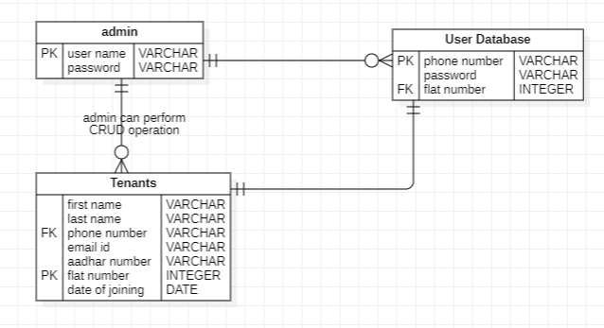

**Usecase diagram :**

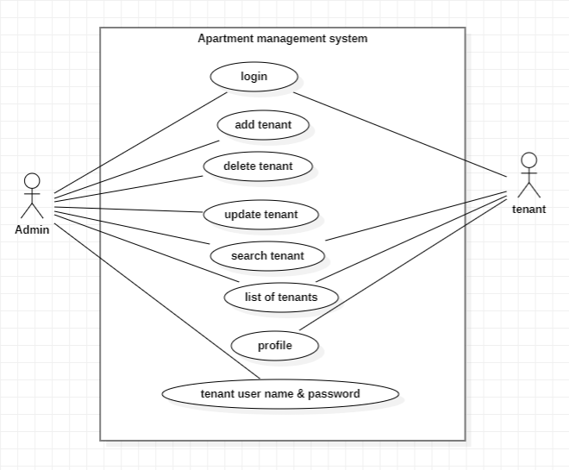

**1. Admin**

* **Add tenant:** admin can add tenant’s details and their login id and password auto-generated.
* **Delete tenant:** admin can delete tenant records by tenant flat number if the tenant is valid.
* **Update tenant:** admin can update the tenant’s records.
* **List of tenants:** admin can see the list of tenants present in the apartment.
* **Search tenant:** admin can search tenant details using their flat number.
* **Tenant login id and password:** admin can see the tenant login id and password.

**2. user**

* **user profile:** user can check his profile.
* **List of tenants:** users can see the list of tenants present in the apartment.
* **Search tenant:** Users can search tenant details using their flat number.

## **Technical Requirements**

* Backend – java
* Database – MYSQL
* Language – Java